# [**Analyzing with SonarQube Scanner for Ant**](https://docs.sonarqube.org/display/SCAN/Analyzing+with+SonarQube+Scanner+for+Ant)

Instruction to analyze projects using SonarQube

1. Install latest version of ANT.

Tutorial for installing and running ANT

i.) Get ANT from [Apache Ant website](http://ant.apache.org/bindownload.cgi) and get the tar.gz file.

Refer: <https://www.mkyong.com/ant/how-to-apache-ant-on-mac-os-x/>

ii.) Extract it using tar vxf apache-ant-1.9.4-bin.tar.gz

a.Navigate to bin folder under Apache Ant folder and

b**.** Run **ant -v**

Something like this would be printed if you have correctly install ANT

**Apache Ant(TM) version 1.9.4 compiled on April 29 2014  
Trying the default build file: build.xml  
Buildfile: build.xml does not exist!  
Build failed**

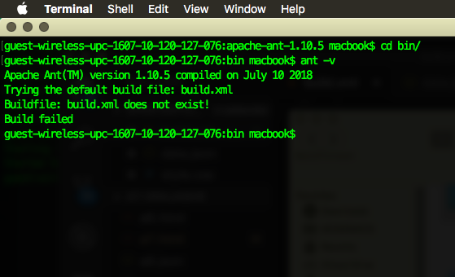

2. Setup the environmental variables for ANT

* vim ~/.bash_profile
* export JAVA_HOME=$(/usr/libexec/java_home)  
  export GRADLE_HOME=/Users/macbook/gradle  
  export M2_HOME=/Users/macbook/apache-maven-3.5.4  
  # Apache Ant  
  export ANT_HOME=/Users/macbook/apache-ant-1.9.4  
  # Export to PATH  
  export PATH=$PATH:$GRADLE_HOME/bin:$M2_HOME/bin:$ANT_HOME/bin
* Now you should be able to run the ant -v command anywhere

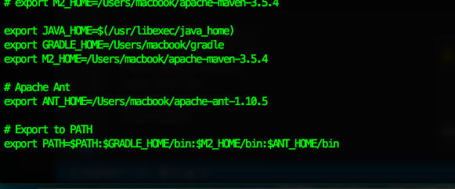

3. In order to use ant with sonarqube try running

Follow instructions on this page :

<https://docs.sonarqube.org/display/SCAN/Analyzing+with+SonarQube+Scanner+for+Ant>

i.) Define a new sonar Ant target in your Ant build script:

xmlns:sonar="antlib:org.sonar.ant"

Add this in the build file.

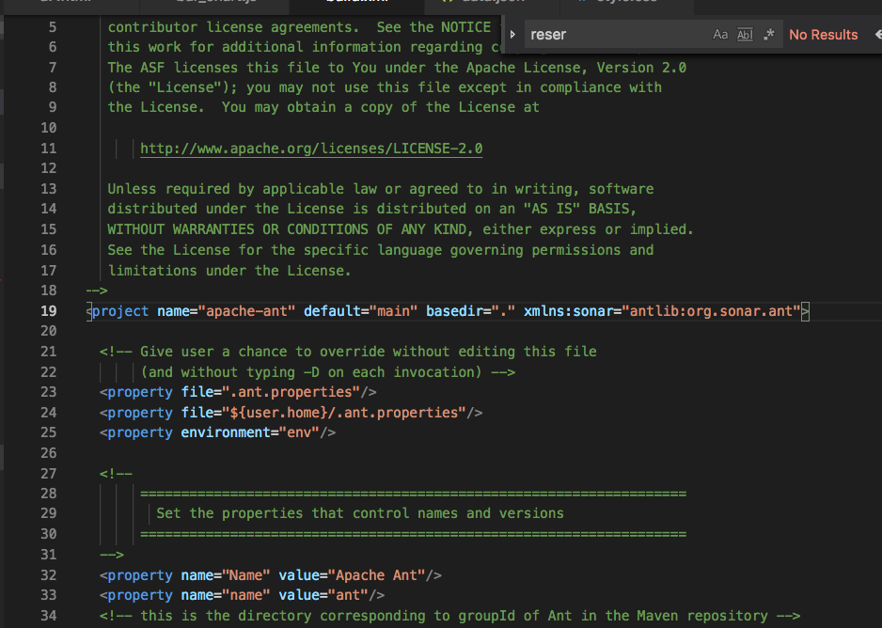

ii.)Define the SonarQube global properties (the most usual way is to pass these properties via the command line)

Add this next:

<property name="sonar.host.url" value="[http://localhost:9000"](http://localhost:9000/) />

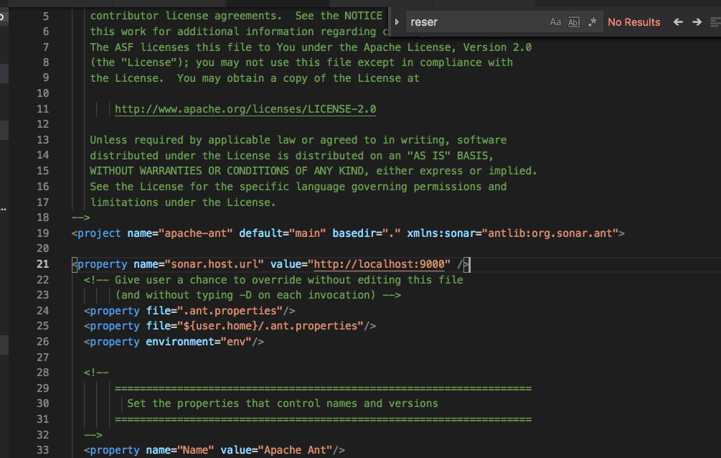

iii.)Define the SonarQube project properties -

* Change the values with respective project name you are trying to build for name=”sonar.projectKey”
* And name=”sonar.projectName”

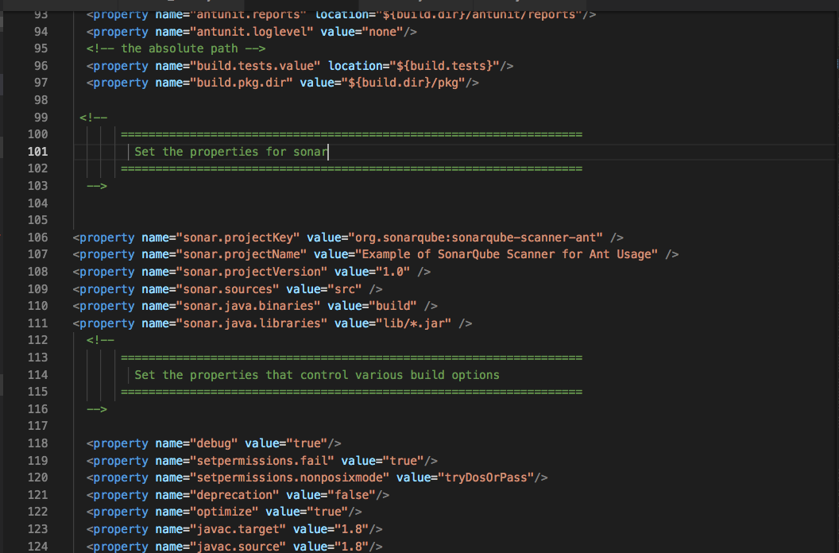

Check if there is src, common and lib folder with jar files as per the error which would pop up on executing “ant sonar”

iv.)Define SonarQube Scanner for Ant Target

Add this to build file and in this for the highlighted line download the sonar jar file from link below and give the respective path below.

<target name="sonar">

<taskdef uri="antlib:org.sonar.ant" resource="org/sonar/ant/antlib.xml">

<!-- Update the following line, or put the "sonarqube-ant-task-*.jar" file in your "$HOME/.ant/lib" folder -->

<classpath path="path/to/sonar/ant/task/lib/sonarqube-ant-task-2.5" />

</taskdef>

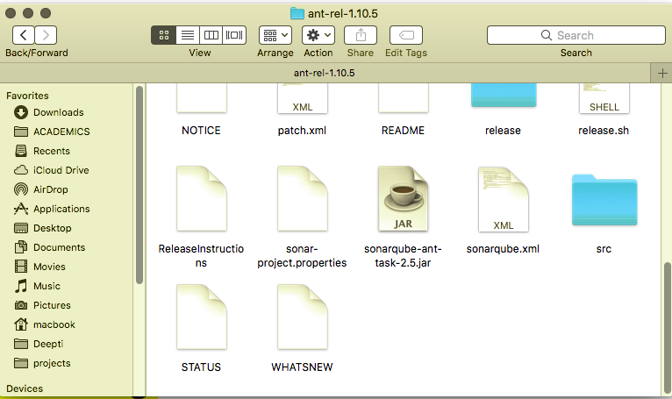

Can have it in your project folder like shown above.

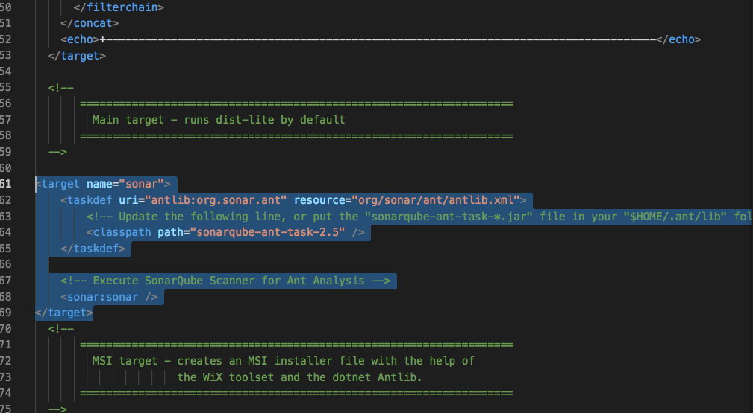

v.)Run the following command from the project base directory to launch the analysis:

**Ant sonar**